**Image Segmentation**

**Latest Submission Grade 100%**

**1.**

Question 1

At the heart of image segmentation with neural networks is an encoder/decoder architecture. What functionalities do they perform ?

**1 / 1 point**



The encoder extracts features from an image and the decoder takes those extracted features, and assigns class labels to each pixel of the image.

**Correct**

Correct!

**2.**

Question 2

Is the following statement true regarding SegNet, UNet and Fully Convolutional Neural Networks (FCNNs):

*Unlike the similarity between the architecture design of SegNet & UNet, FCNNs do not have a symmetric architecture design.*

**1 / 1 point**



True

**Correct**

Correct!

**3.**

Question 3

What architectural difference does the *number*represent in the names of FCN-32, FCN-16, FCN-8 ?

**1 / 1 point**



The *number* represents the factor by which the final pooling layer in the architecture up-samples the image to make predictions.

**Correct**

Correct!

**4.**

Question 4

Take a look at the following code and select the type of scaling that will be performed

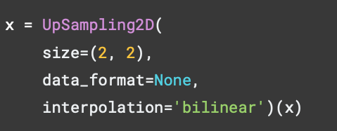

**1 / 1 point**



The upsampling of the image will be done by means of linear interpolation from the closest pixel values

**Correct**

Correct!

**5.**

Question 5

What does the following code do?

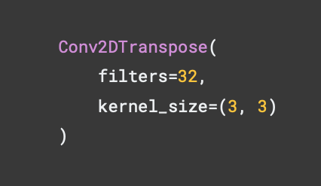

**1 / 1 point**



It takes the pixel values and filters and tries to reverse the convolution process to return back a 3x3 array which *could* have been the original array of the image.

**Correct**

Correct!

**6.**

Question 6

The following is the code for the *last layer* of a FCN-8 decoder. What *key change* is required if we want this to be the *last layer* of a FCN-16 decoder ?

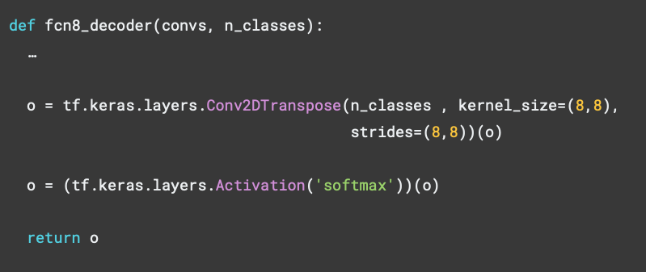

**1 / 1 point**



*kernel_size=(16, 16)*

**Correct**

Correct!

**7.**

Question 7

Which of the following is true about Intersection Over Union (IoU) and Dice Score, when it comes to evaluating image segmentation? (Choose all that apply.)

**1 / 1 point**



Both have a range between 0 and 1

**Correct**

Correct!



For IoU the numerator is the area of overlap for both the labels, predicted and ground truth, whereas for Dice Score the numerator is 2 times that.

**Correct**

Correct!

**8.**

Question 8

Consider the following code for building the *encoder blocks* for a *U-Net*. What should this function return?

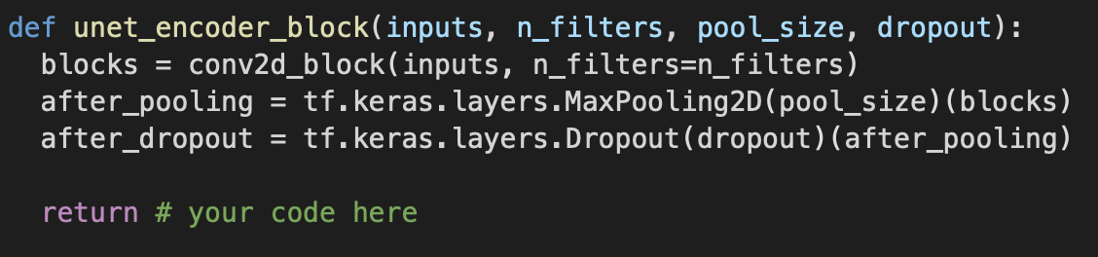

**1 / 1 point**



*blocks*, *after_dropout*

**Correct**

Correct!

**9.**

Question 9

For U-Net, on the *decoder* side you combine *skip connections* which come from the corresponding level of the *encoder*. Consider the following code and provide the missing line required to account for those skip connections with the upsampling.

(**Important Notes**: Use TensorFlow as *tf*, Keras as *keras*. And be mindful of python spacing convention, i.e (x, y) *not* (x,y) )

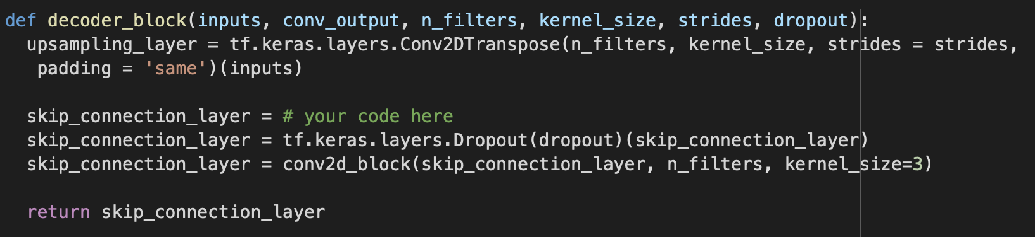

**1 / 1 point**

tf.keras.layers.concatenate([upsampling_layer, conv_output])

**Correct**

Correct!